**DATA SCIENCE**

**(Project)**



**PROJECT TITLE**

FINAL PROJECT S2022 (PAKISTAN STOCK PRICE PRIDICTION MODEL)

**SUBMITTED TO:**

MAZHAR JAVED AWAN

**Submitted By:**

MUHAMMAD HUSNAIN YUSUFI

F2019065005

Introduction:

Stock market prediction is the act of trying to determine the future value of company stock or other financial instruments traded on an exchange.

The successful prediction of a stock’s future price could yield a significant profit. In this application, we used the LSTM network to predict the closing stock price using the past 60-day stock price.

For this prediction model I have used LSTM model. LSTM stands for LONG SHORT TERM MEMORY

1: By mounting my colab to google drive

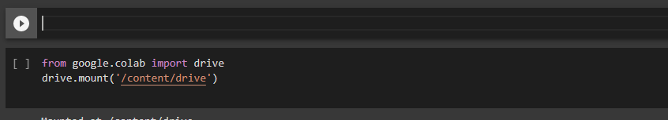

2: Importing all of the necessary libraries

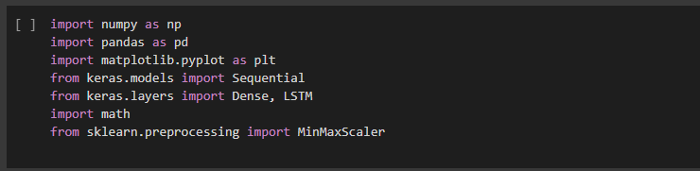

Here I create the dataset/ datafram by using pandas’ library and import dataset.



Using head function to show the first five rows of our dataframe

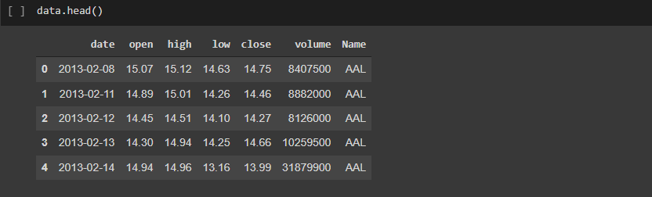

Choosing Pakistan Stock from our dataset

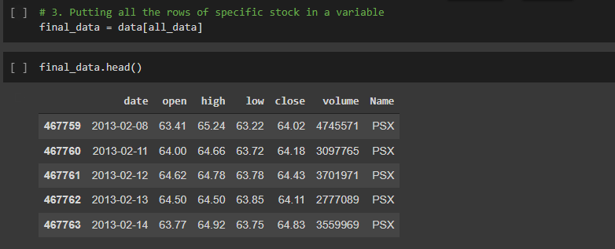

Visualizing the data of stocks. This is the Date Vs Close market chart

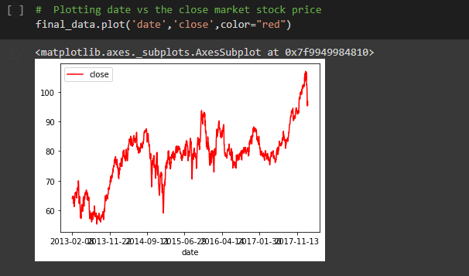

Now visualizing the data for last 60days to understand it properly. We will cross tab the Date Vs Closing of the last 60days.

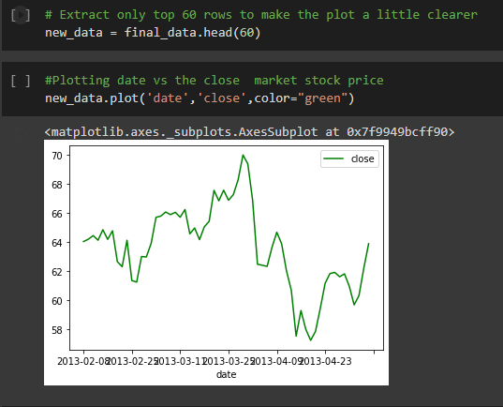

Now plotting Date vs High of last 60days of the market

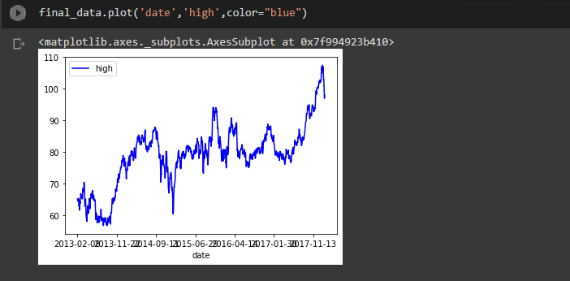

Now visualizing Date vs Low of last 60days.

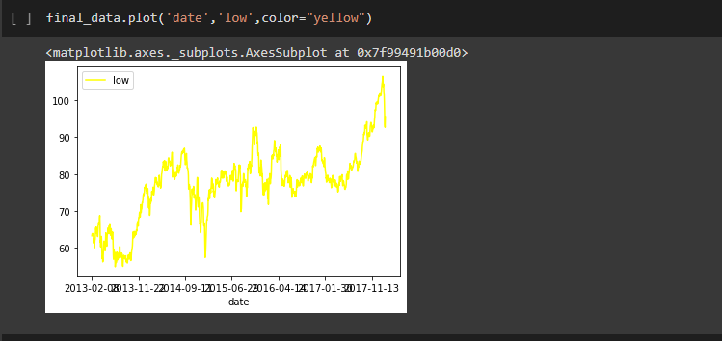

Now visualizing Date Vs total Volume of last 60days

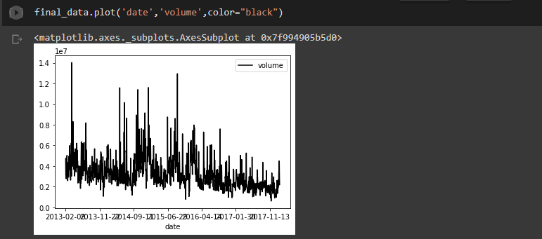

**Creating New Data Frame and Training Data**

To make our study easier we will only consider the closing market price and predict the closing market price.

Filtering out the closing market price data

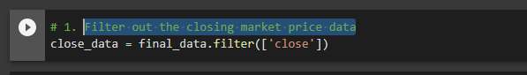

Converting Data frame into array for easy evaluation



Scaling the Dataset to make all values between 0 and 1

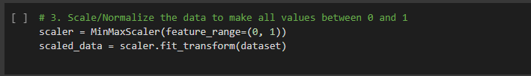

Creating Training dataset of 70%

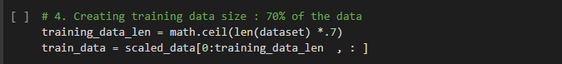

Splitting the Dataset into Training X and Y

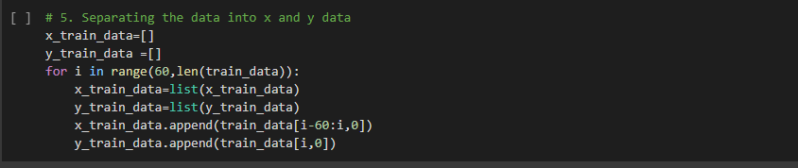

Converting training X and Y into numpy arrays



Putting the training Data into LSTM Model

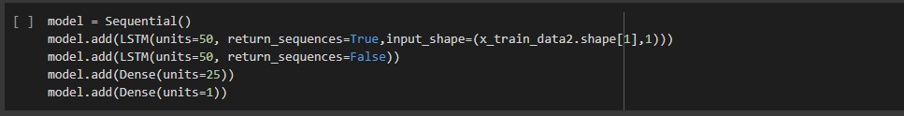

Evaluating our model   
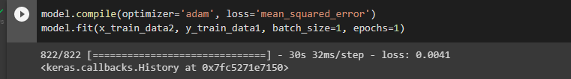

Now creating the dataset for testing

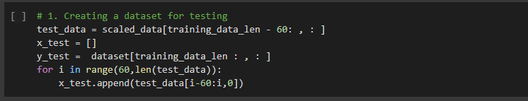

Converting testing dataset into numpy arrays for easy computation.

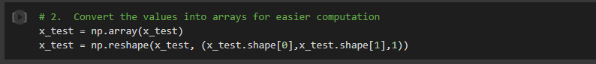

Making prediction of testing Dataset we created

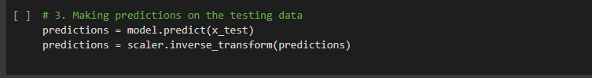

**Error Calculation**

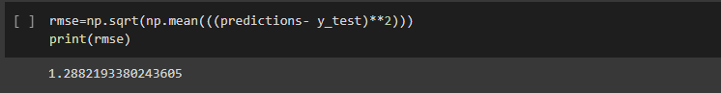RMSE is the root mean squared error, which helps to measure the accuracy of the model. Calculating Error via RMSE.

**Making The Predicitons**

The final step is to plot and visualize the data. To visualize the data we use these basic functions like title, label, plot as per how we want our graph to look like

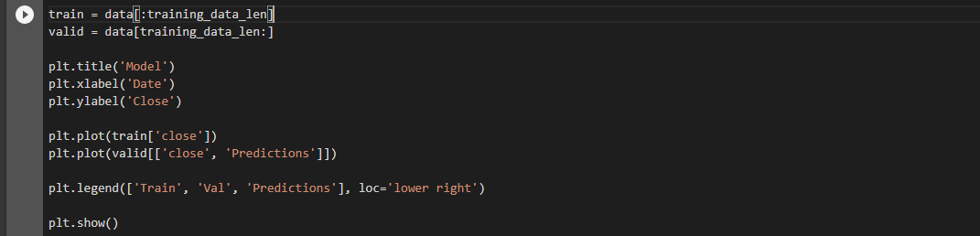

Plotting actuall vs predicted values.

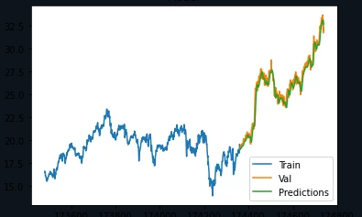

Printing Actual Vs Predicated values we obtain from our Model

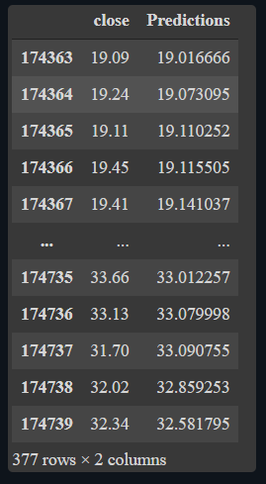

**Conclusion**

If we look closely LSTM has obtain very close predicated values. The stock price prediction is tough because we have to do Time series analysis on it.